**USAA Cruise Site Display Update**

This request is to update the OVS Cruise display for the USAA Explore Cruise Travel site. There are two basic changes being requested:

1. Remove Points Redemption Level drop down and replace with GVR-like integrated points display.

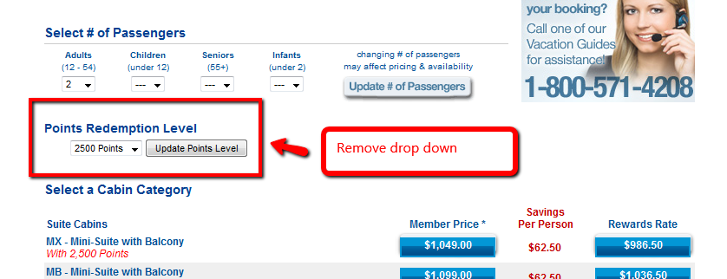

* Replace drop down with GVR-like display where all points levels are integrated up to 10,000 points level (based on member points balance)

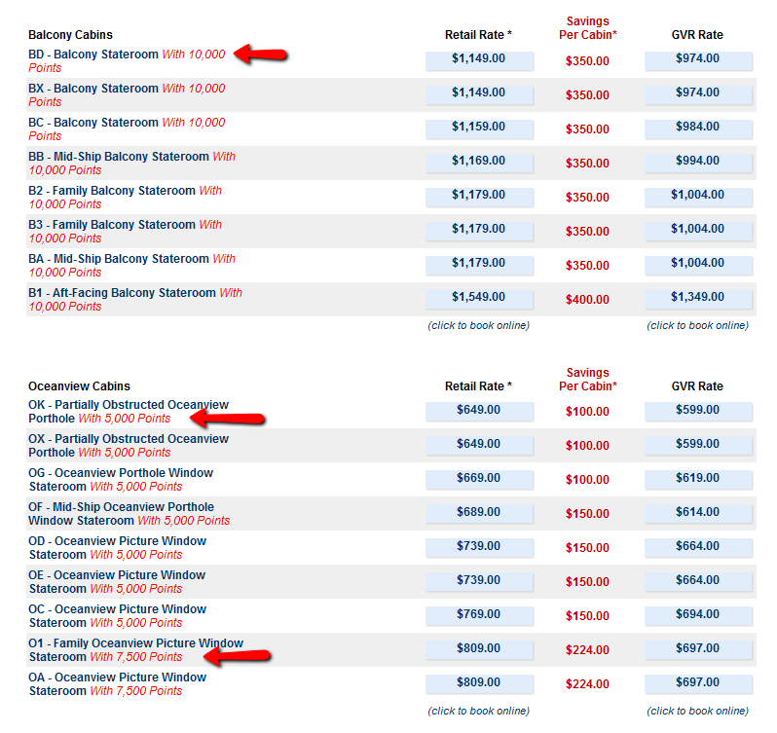

1. Update pricing/savings column headers and display savings per cabin

